**EXPERIMENT NO.10**

AIM: To design a BCD adder.

IC USED: 7483A (4-bit adder), 7408(AND), 7432(OR).

THEORY:

is possible to perform addition in BCD by first adding in binary, and then converting to BCD afterwards. Conversion of the simple sum of two digits can be done by adding 6 (that is, 16 – 10) when the result has a value greater than 9.

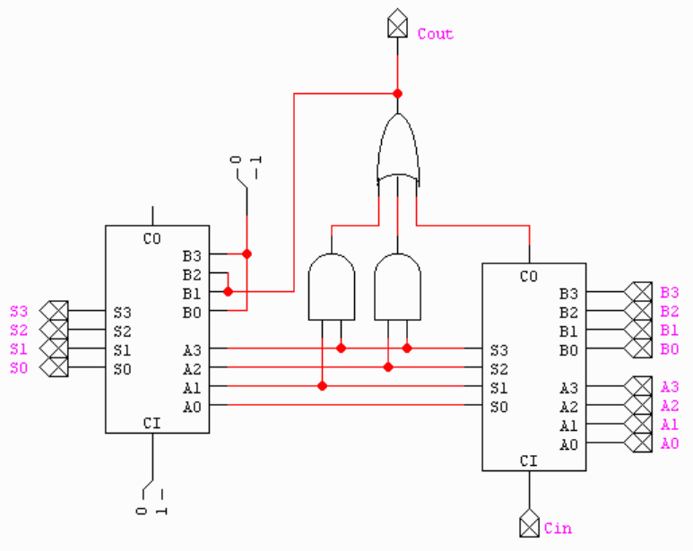

For example:

1001 + 1000 = 10001 = 0001 0001

9 + 8 = 17 = 1 1

In BCD, there cannot exist a value greater than 9 (1001) per nibble. To correct this, 6 (0110) is added to that sum to get the correct first two digits:

0001 0001 + 0000 0110 = 0001 0111

1 1 + 0 6 = 1 7

This gives two nibbles, 0001 and 0111, which correspond to the digits "1" and "7". This yields "17" in BCD, which is the correct result. This technique can be extended to adding multiple digits, by adding in groups from right to left, propagating the second digit as a carry, always comparing the 5-bit result of each digit-pair sum to 9.

SCHEMATIC: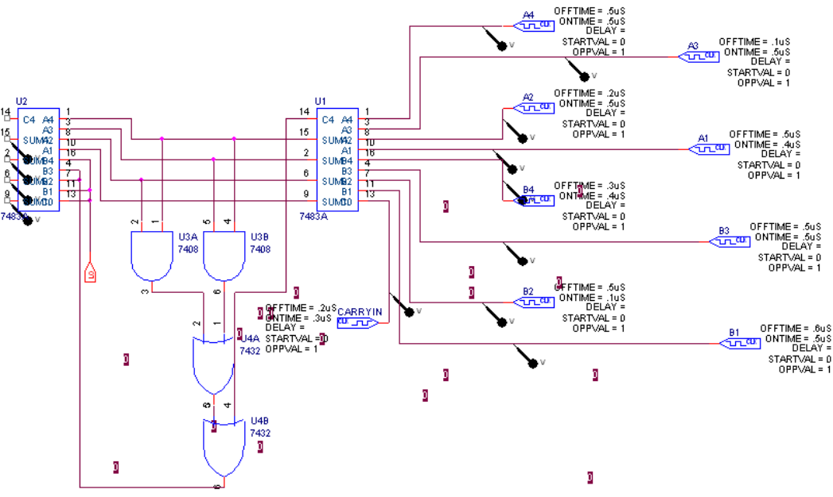

WAVEFORM:

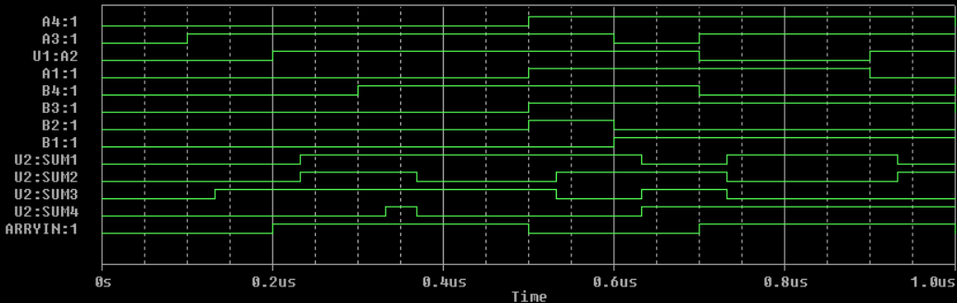

RESULT: BCD adder is designed and output is verified.